Spring Batch is single node bulk offline batch system.

Hadoop is an offline distributed processing batch system..

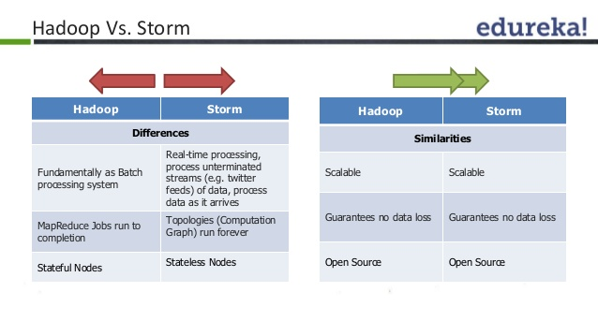

Apache Storm is real time distributed batch processor. Ex: User can give an GBs of file in many nodes and ask to give report

At Groupon Storm is used to build real-time data integration systems. Storm helps us analyze, clean, normalize, and resolve large amounts of non-unique data points with low latency and high throughput.

Apache Storm, with Redis, Kafka and Netty for real-time data analytic

system, and triggering real-time actions from statistical data

Primarily Apache Storm is 'stream processing' engine which works in 'real-time' unlike the Apache Spark (which claims to be 'stream processing', but works in batched-mode not really real-time). Many analytics uses cases revolve around 'real time stream processing' rather than batched mode (like hadoop or spark)